**Graduate Research Plan Statement**

Coral Pichardo

N-heterocyclic carbenes are proving to be more and more effective in many catalytic reactions, as opposed to traditionally utilized ligands. These complexes are being tested for many uses because of their unique bonding, such as their potential uses as photosensitizers and selective catalysts for hydroamination reactions. Hydroamination catalysts derived from late transition metals are very chemically rich. “The d8/d10 metal species associated with these catalysts and their ability to act as Lewis Acids provide a high degree of activity toward hydroamination by varied mechanistic pathways.” (2) These complexes generally show low reactivity with air and water, and so are not restricted to reactions in organic solvents. “Cationic RhⅠ complexes with chelating N-donor ligands are known to catalyze intramolecular hydroamination of amino alkynes, amino alcohols and amino carboxylic acids.” (1)

An article was found describing carbene ligands being bonded to rhodium for use as hydroamination catalysts where the reactions were performed under inert atmosphere and took place at or near room temperature. A former student has already synthesized a derivative of the starting ligand for this reaction, methylated 1-[1-(1H-imidazole-1-yl)-2,2-diphenylethenyl]-1H-imidazole, which was nicknamed MDEtH (Figure 2). The derivative of the starting ligand extends the structure with large phenyl rings, locking the configuration into planar form, which is not the case in the literature.

Figure 1. Starting Ligand Found in Literature Figure 2. Derivative Ligand (MDEtH)

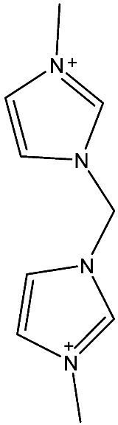 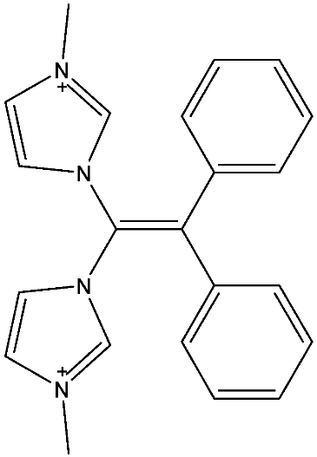

Gaussian will be used to measure the energy of the final product to see if this synthesis is plausible. This final molecule will be built using Gauss view in two parts, first just the ligand shown in Figure 2, and then the final product. For the ligand, the job type will first be set to “Optimization” and run under a 3-21G basis set using a DFT method. Once the optimization of the molecule is run, the job type will be changed to “Energy”. The basis set will consecutively be changed from, 3-21G, 6-31G, 6-311G all using the functional B3LYP. After each of these “Energy” jobs are run, the next and final job type used will be “Opt-Freq”. Under the “Opt-Freq” job type, and the basis set will be 6-311G with 2d and 2p orbitals included. The same will be done for the final product, however the functional will be changed to M06 to account for the Rhodium, as well as the additional basis set LANL2DZ for both the final “Energy” and the “Opt-Freq” job types. For all of these calculations, the molecule’s charge will be included under the basis set in the calculation set up. From the “Opt-Freq” run, the .log file will be opened to obtain the Thermo values from the results summary.

Once it is determined that the final product has a plausible energy in Gaussian, a synthetic method was designed for the attachment of MDEtH to a rhodium with bound cyclooctadiene (Figure 3), using the literature as a guide.

Figure 3. Reaction scheme for attachment of MDEtH to the Rh complex

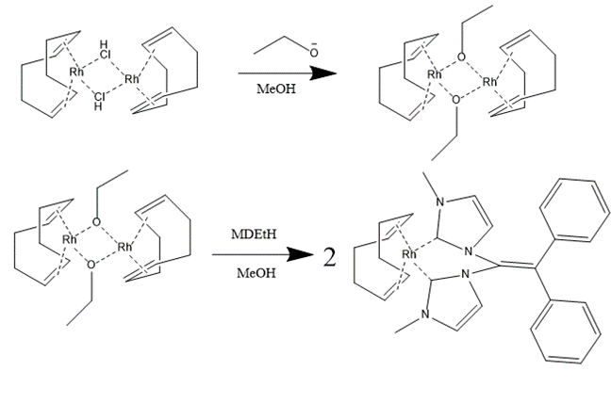

Once the Rh complex is attached to the ligand, the next step is to remove cyclooctadiene from the complex and replace it with two carbonyls. The catalytic properties of the compounds will be examined.

**Intellectual Merit**

The final product will be tested as a hydroamination catalyst and compared to those tested in Burling et al. This comparison will tell us how the large aromatic system affects the catalytic activity.

**Broader Impacts**

If this experiment proves to be successful, this opens up the opportunity of new possibilities of catalysts with large aromatic systems. Decreasing the need for organic solvents in the synthesis of these catalysts will also have a positive environmental impact in reducing the amount of waste produced.

**References**

1. Burling, S., Field, L. D., Li, H. L., Messerle, B. A., & Turner, P. (2003). Mononuclear rhodium(I) complexes with chelating N-heterocyclic carbene ligands - Catalytic activity for intramolecular hydroamination. European Journal of Inorganic Chemistry, (17), 3179-3184
2. Libretexts. Hydroamination. <https://chem.libretexts.org/Bookshelves/Inorganic_Chemistry/Supplemental_Modules_(Inorganic_Chemistry)/Catalysis/Catalyst_Examples/Hydroamination>
3. Gaussian 16, Revision C.01, M. J. Frisch, G. W. Trucks, H. B. Schlegel, G. E. Scuseria, M. A. Robb, J. R. Cheeseman, G. Scalmani, V. Barone, G. A. Petersson, H. Nakatsuji, X. Li, M. Caricato, A. V. Marenich, J. Bloino, B. G. Janesko, R. Gomperts, B. Mennucci, H. P. Hratchian, J. V. Ortiz, A. F. Izmaylov, J. L. Sonnenberg, D. Williams-Young, F. Ding, F. Lipparini, F. Egidi, J. Goings, B. Peng, A. Petrone, T. Henderson, D. Ranasinghe, V. G. Zakrzewski, J. Gao, N. Rega, G. Zheng, W. Liang, M. Hada, M. Ehara, K. Toyota, R. Fukuda, J. Hasegawa, M. Ishida, T. Nakajima, Y. Honda, O. Kitao, H. Nakai, T. Vreven, K. Throssell, J. A. Montgomery, Jr., J. E. Peralta, F. Ogliaro, M. J. Bearpark, J. J. Heyd, E. N. Brothers, K. N. Kudin, V. N. Staroverov, T. A. Keith, R. Kobayashi, J. Normand, K. Raghavachari, A. P. Rendell, J. C. Burant, S. S. Iyengar, J. Tomasi, M. Cossi, J. M. Millam, M. Klene, C. Adamo, R. Cammi, J. W. Ochterski, R. L. Martin, K. Morokuma, O. Farkas, J. B. Foresman, and D. J. Fox, Gaussian, Inc., Wallingford CT, 2016. <https://gaussian.com/citation/>